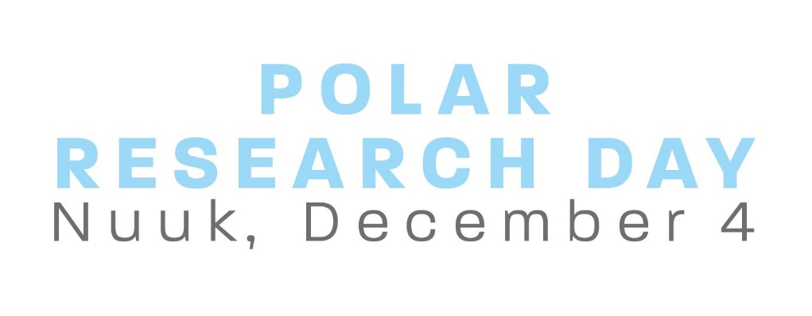
Connecting Science and Communities
Nuuk, Greenland - December 4 2019

9:00–9:45 Welcome and introductory keynote
- Welcome by Allan Peter Olsen, Greenland Perspective
- Introducing Greenland Research Council: Reflections on connecting communities and science and on research strategies in Greenland, by chair Josephine Nymand

9:45-10:30 Local and Indigenous Knowledge in Science

10:30 – 11:00 BREAK

11:00 – 12:00 Arctic Thematic Network Panels (moderated by Lill Rastad Bjørst, AAU Arctic)
Chairs from Arctic thematic networks present about their network activities and opportunities to join. Five minutes presentation each and subsequent dialogue on the relevance of the ongoing research for communities.

12:00–13:00 LUNCH AND EXHIBITION

13:00-14:00 Climate Research in Greenland (moderated by Acting Head of Department, Mie S. Winding, Greenland Climate Research Center)
Greenland Climate Research Center in Greenland to present status and results and future prospects
Climate research at Greenland Institute of Natural Resources

14:00-15:00 Research Communication Panel (moderated by Anne Merrild Hansen, AAU Arctic)

15:00-15:45 BREAK

16:00–17:30 NEW RESEARCH ANNO 2019 ~ 6 Greenlandic PhD’s/Post-docs (moderated by Rasmus Leander Nielsen, University of Greenland)

17:30–18:00 Final keynote: Thirty years of Arctic Research, network, capacity building and reflections on how to connect science and communities, by Professor Morten Melgaard, University of Greenland

18:30–21:30 DINNER

